SOFTWARE REQUIREMENT SPECIFICATION

PAYROLL MANAGEMENT

1.INTRODUCTION

Payroll system is the heart of any Human Resource System of an organization. The company has to take care of the calculation of salary as per rules of the company, income tax calculation and various deductions to be done from the salary including statutory deductions like Income tax and Provident fund deductions. It has to generate pay-slip, cheque summary and MIS reports. So, this SRS report is a case study for system analysis of Payroll System, and the study is clear comprehensive view about this system, and how we can design a system for this Payroll.

* 1. PURPOSE

Main aim of developing Employee Payroll System is to provide an easy way not only to automate all functionalities involved managing leaves and Payroll for the employees of Company, but also to provide full functional reports to management of Company with the details about usage of leave facility.

* 1. MOTIVATION

The need for automating recurring processes like generating pay-slip, calculating tax deduction etc is the main motivation towards making a payroll management system. An error free and quick solution for all the hassles related to paying the employees can be resolved by a user-friendly system.

* 1. REFERENCES
* <https://www.geeksforgeeks.org/>
* <https://www.javatpoint.com/>
* <https://www.rcciit.org/>

2.REQUIREMENTS

2.1 FUNCTIONAL REQUIREMENT

ADMIN:

This module helps in employee management. Admin can add and manage employees.

EMPLOYEE:

This module helps in viewing employee details and payslip.

2.2 SOFTWARE REQUIREMENT

* Operating System : Ubuntu
* Programming language : C
* Database : Files

2.3 HARDWARE REQUIREMENTS

* Memory minimum of 1 GB RAM
* Hard disk of 40 GB
* Monitor
* Mouse
* Keyboard
* Printer

3.DESIGN AND IMPLEMENTATION

3.1 PRODUCT FEATURES

* RELIABILITY

In order to ensure reliability, this system is being designed using software that is established to be stable and easy to use.

* AVAILABILITY

This system is designed to run 24/7 and be readily available to the user

* SECURITY

The access to the software is given only to valid operators. We need a specific ID and password to get access to the software.

* USER FRIENDLY

The software is made user friendly for smooth usage by end user.

3.2 USE CASE DIAGRAM

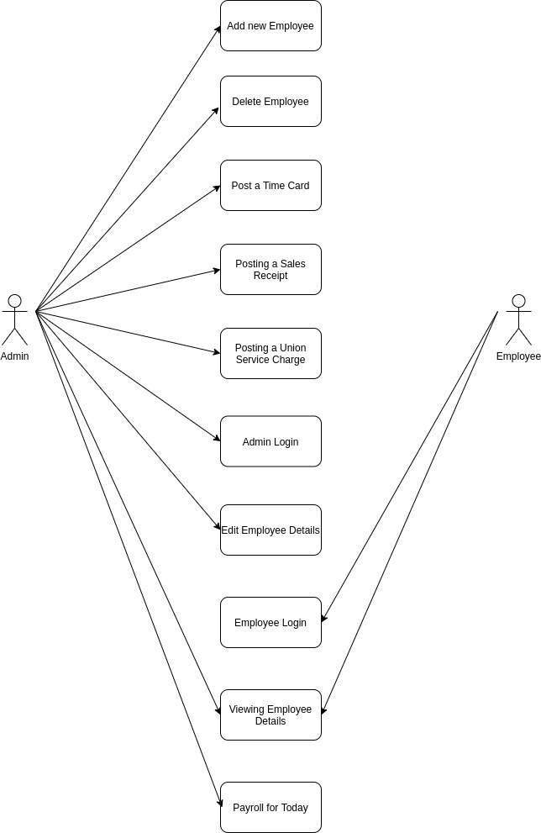

3.3 USER CLASSES AND CHARACTERISTICS

The system will support two types of user privileges, Admin and Employee. Employees will be able to view reports, and the admin will have access to both reports and management functions.

The admin should have following management functionalities:

* Add employee details
* Update employee details
* Search employee details
* Delete employee details
* Generate employee salary slip
* View employee reports
* View salary slips

The employee has following functionalities:

* View employee report
* View salary slip

3.4 SEQUENCE DIAGRAM

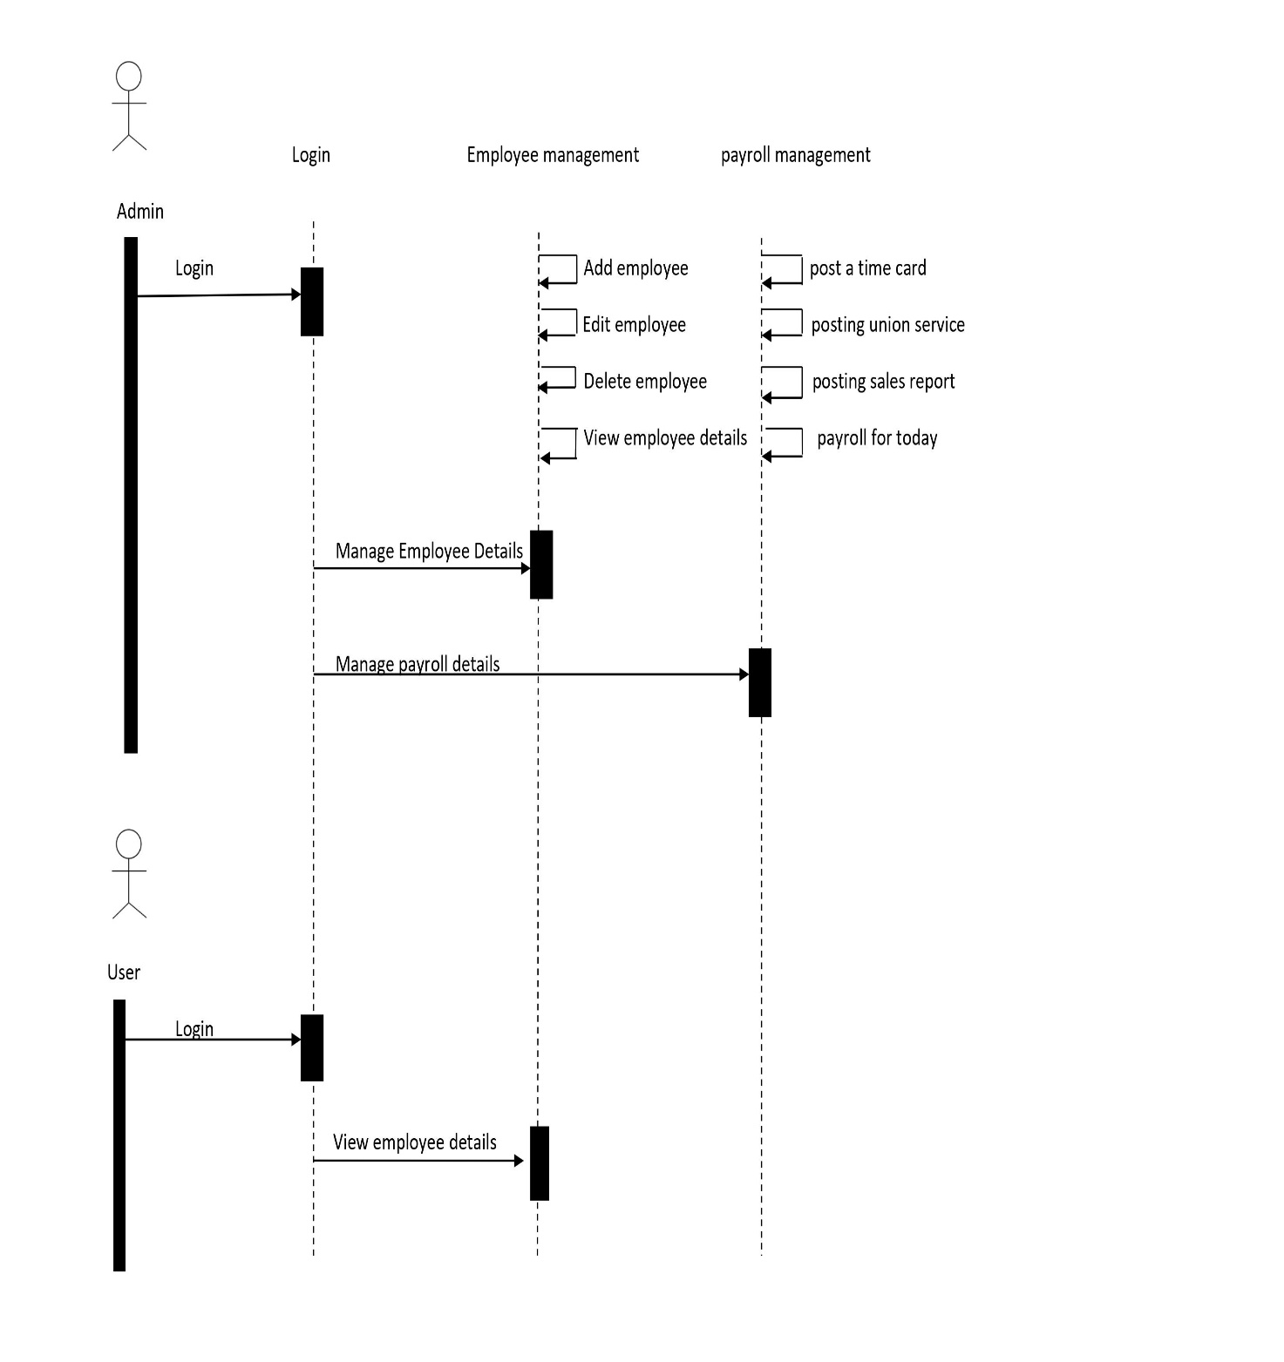

9.BIBLIOGRAPHY